**Bail Reckoner**

**Module 4 : Frontend Development**

**1. Bail Draft Generator**

* Input fields for **Client Name, Client ID, Lawyer Name, and Case Details**.
* Automatically generates a **bail application draft**.
* Simple interface to assist lawyers in drafting bail requests.

### 2. ****Client Management****

* Displays a **Client Roster** with Client ID, Name, and Case Status.
* Status examples: **Awaiting Hearing** or **Bail Granted**.
* Option to **add new clients** for case tracking.

### 3. ****Settings****

* Profile information update: **Full Name, Email, Bar Association ID, Password**.
* **Notification settings** for case status, new client assignments, and hearing reminders.
* Ensures personalized and secure account management.

### 4. ****AI-Assisted Decision Dashboard****

* Upload **case PDFs** for instant summaries and bail recommendations.
* Integrated **Case Inquiry Chat** for interactive assistance.
* Helps judicial authorities with **AI-based decision support**.

### 5. ****Case Archive****

* Stores and displays **past case decisions**.
* Shows details like **Case ID, Defendant, Final Decision, and Date Decided**.
* Provides search functionality for easy retrieval.

### 6. ****Performance Analytics****

* Key insights: **Total Cases Reviewed, Approval Rate, and Average Decision Time**.
* Visual **bar chart** showing case decisions over time.
* Helps track overall system performance and efficiency.

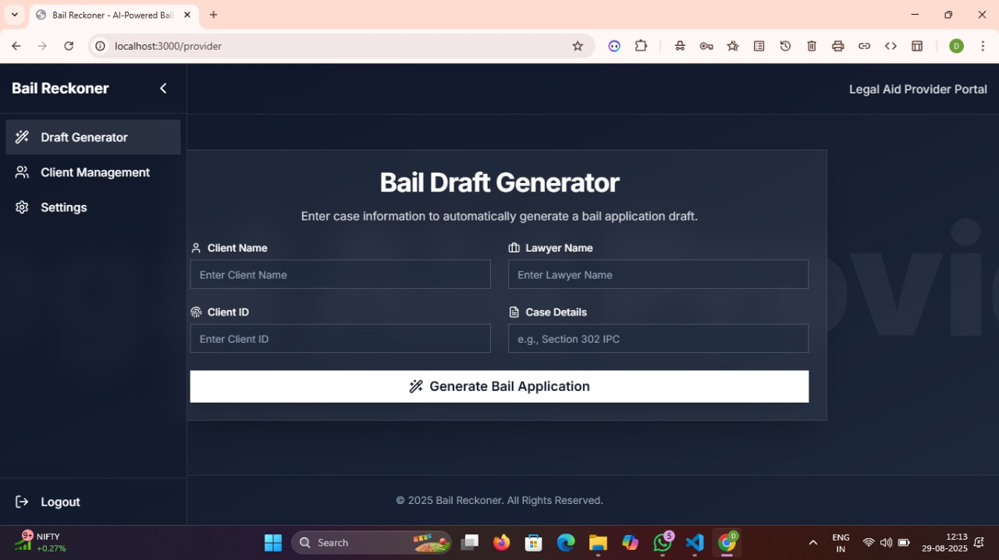

**Fig 1:** **Bail Draft Generator**

This image shows a web application interface called **Bail Reckoner**, specifically the **Bail Draft Generator**. It allows users to enter client details, lawyer information, and case details to automatically generate a bail application draft.

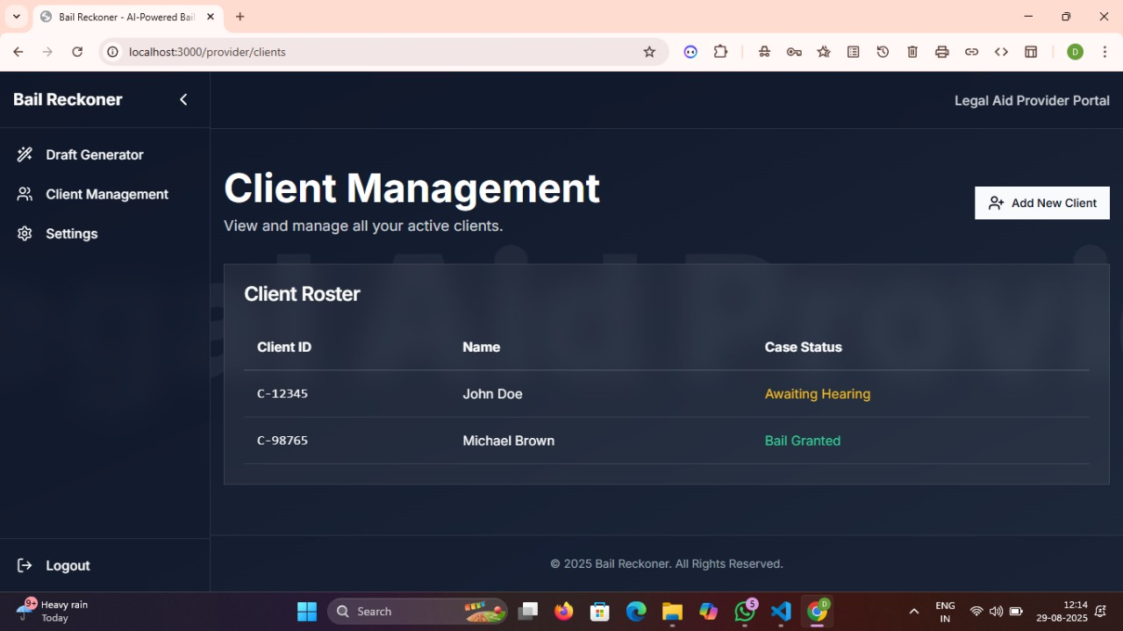

### Fig 2: ****Client Management****

This image shows the **Client Management** section of the Bail Reckoner application. It displays a client roster with details such as Client ID, Name, and Case Status, allowing users to manage clients and add new ones.

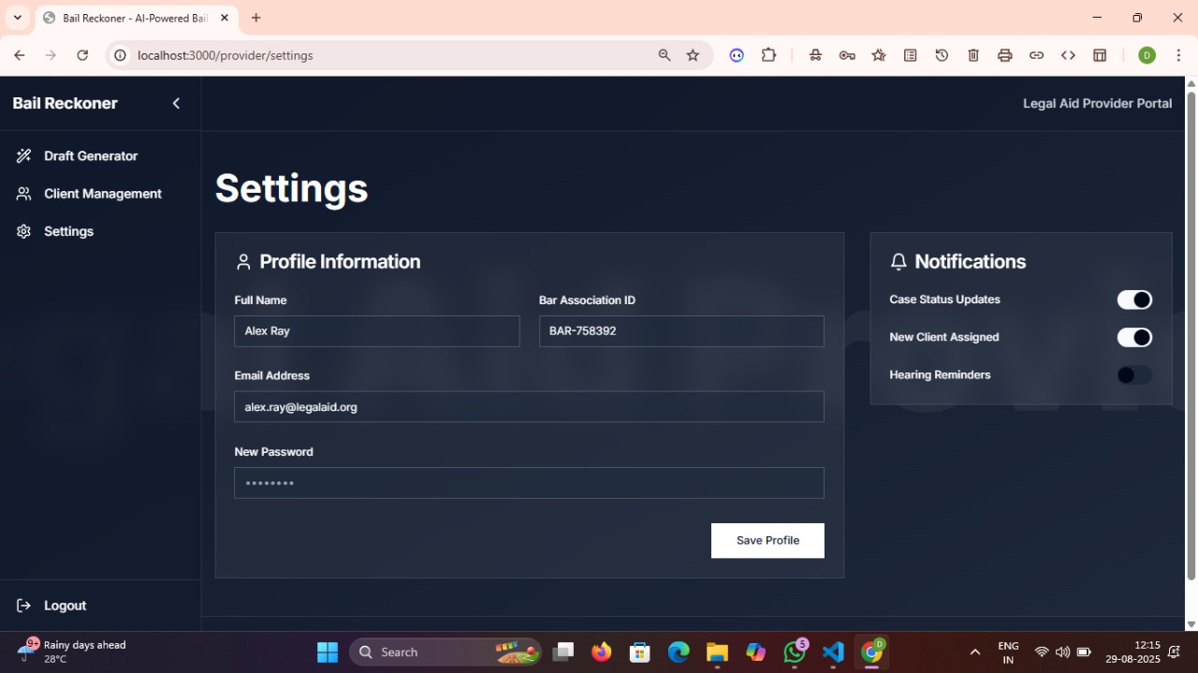

**Fig 3:** **Settings**

This image shows the **Settings** page of the Bail Reckoner application. It allows users to update profile information such as name, email, and password, as well as manage notification preferences for case updates, new clients, and hearing reminders.

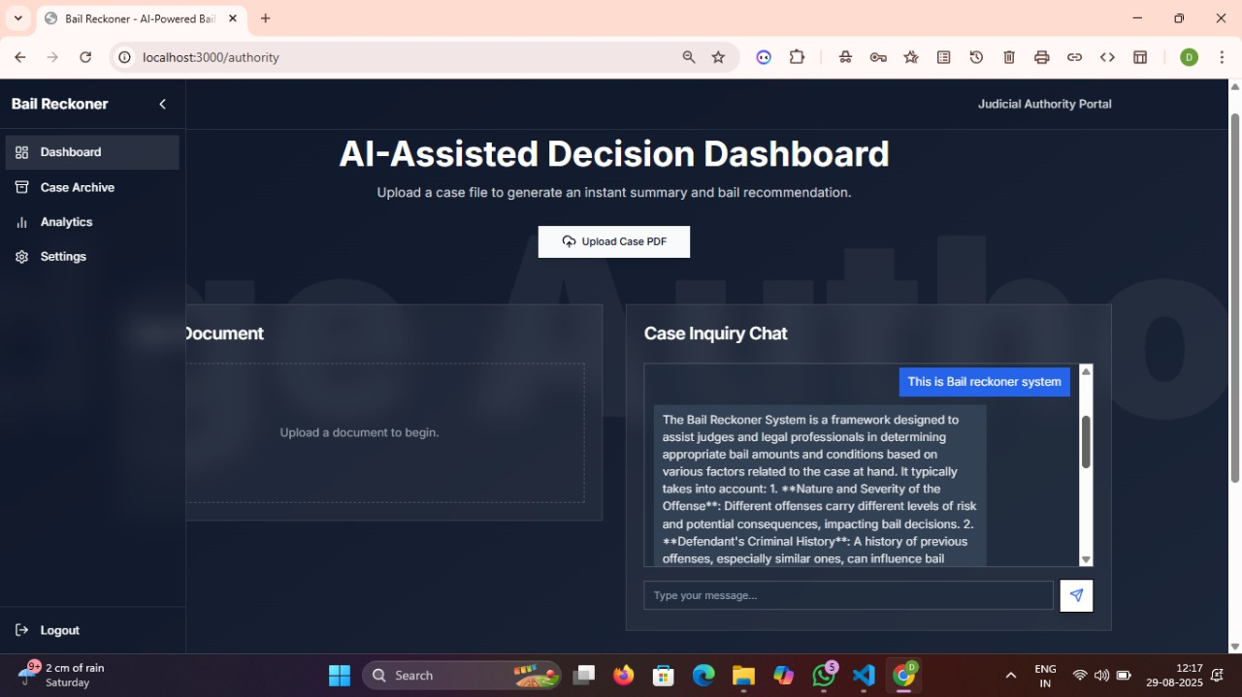

### Fig 4: ****AI-Assisted Decision Dashboard****

This image shows the **AI-Assisted Decision Dashboard** of the Bail Reckoner system. It allows users to upload case files for instant summaries and bail recommendations, along with a **Case Inquiry Chat** for interactive legal assistance.

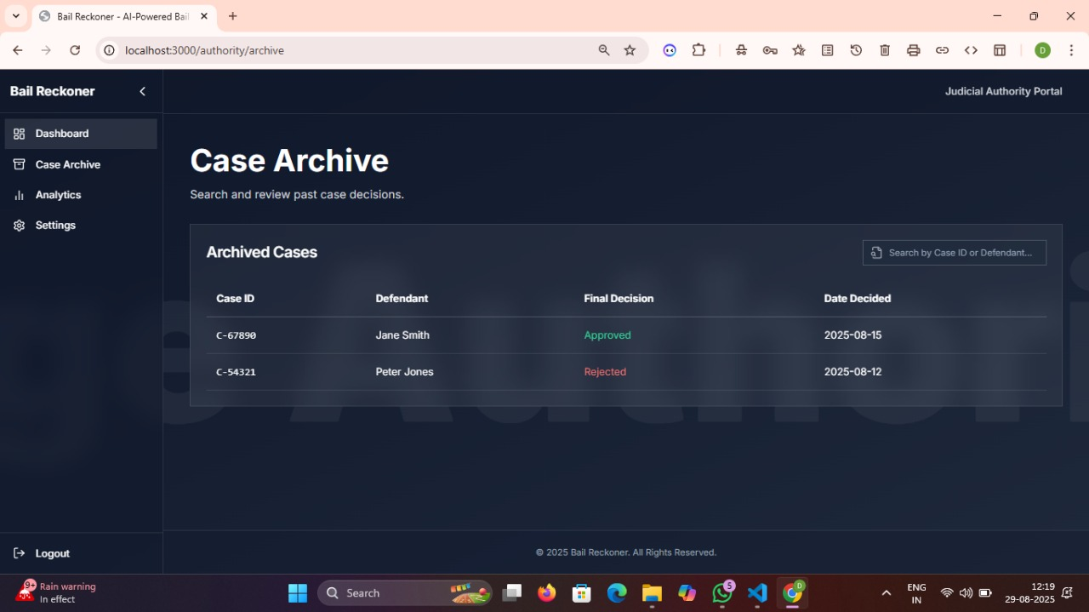

### Fig 5: ****Case Archive****

This image shows the **Case Archive** section of the Bail Reckoner system. It lists past cases with details such as Case ID, Defendant, Final Decision (Approved/Rejected), and the Date Decided, allowing users to review previous case outcomes.

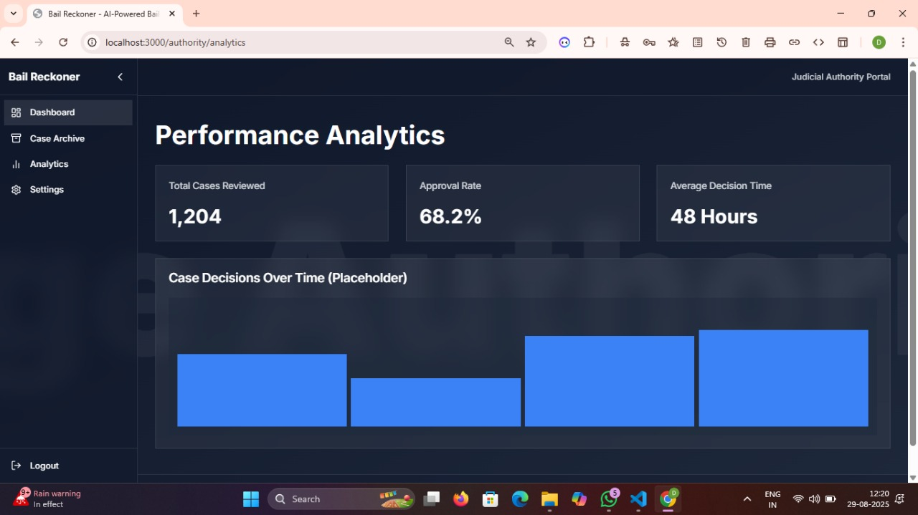

### Fig 6: ****Performance Analytics****

This image shows the **Performance Analytics** dashboard of the Bail Reckoner system. It highlights key metrics such as total cases reviewed (1,204), approval rate (68.2%), average decision time (48 hours), and a bar chart of case decisions over time.